Zeppelin graphs:

Open_Flight Statistics:

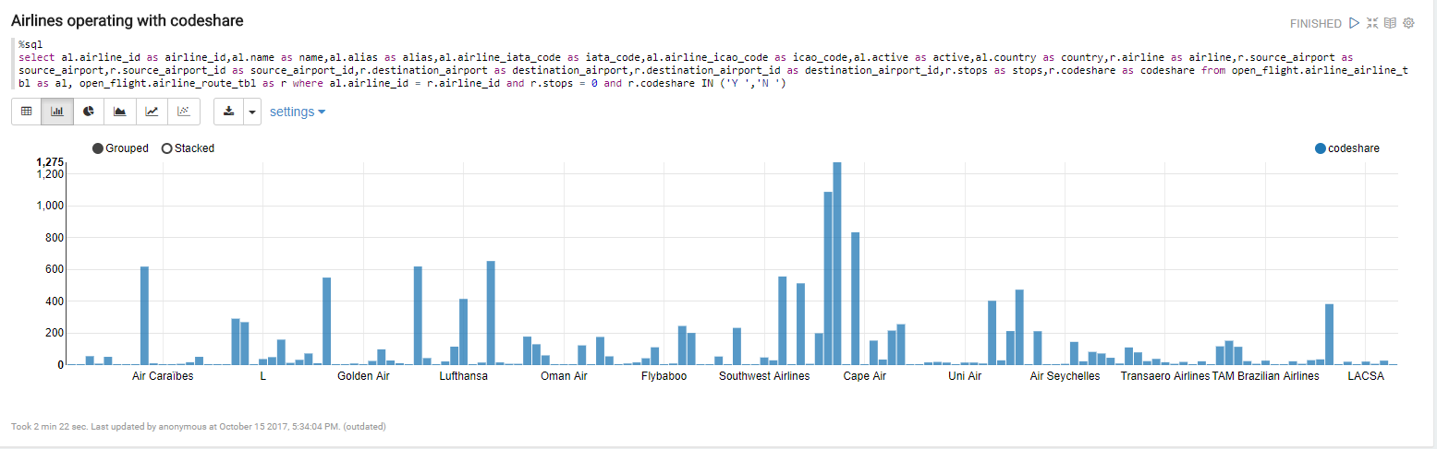

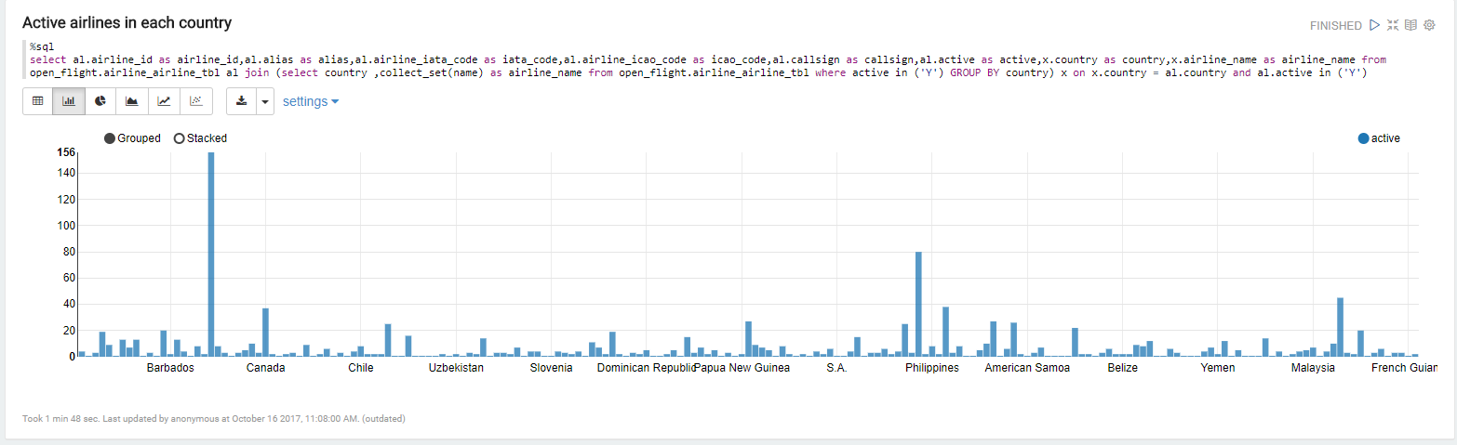

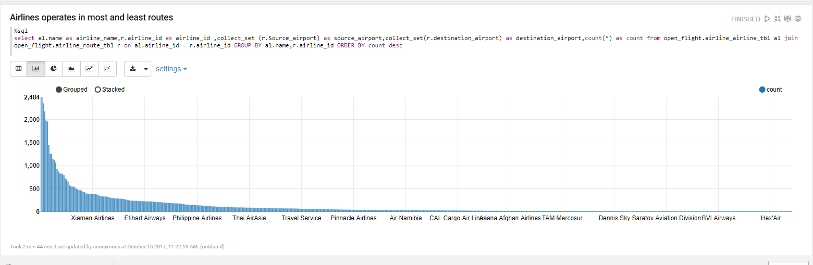

SFO_Statistics:

